[1] CSA-1557 CLOUD COMPUTING LAB PRACTICAL

4.Create a simple cloud software application for Library book reservation system for SIMATS library using any Cloud Service Provider to demonstrate SaaS include the necessary fields such as Title of the book, author, publications, 10 CO1 BL6 Year, edition, no of copies, Rack no, status (taken/returned) etc.

STEP-1:

Login into zoho.com and create an account.Then go to zoho creator and create a new application starting with a new form.Add or insert the required fields.

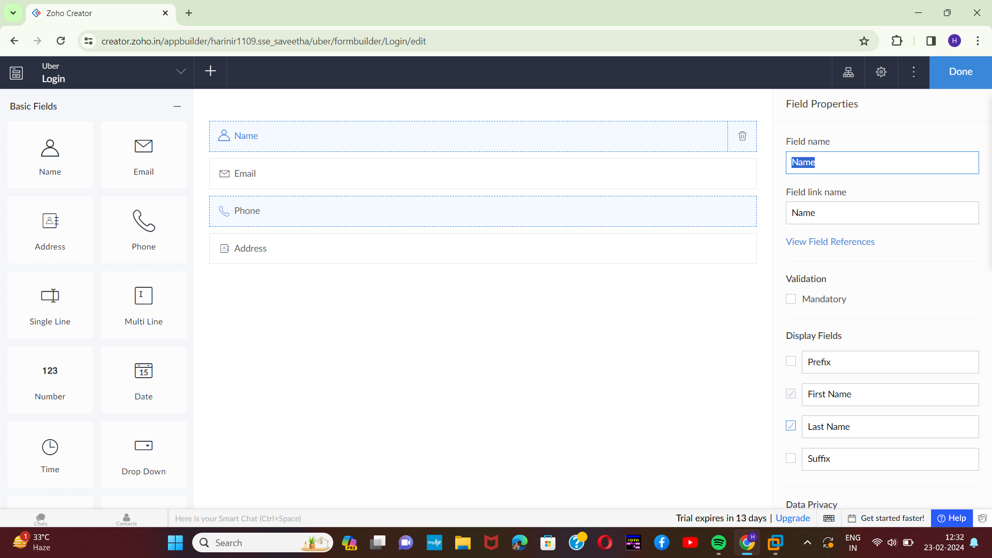

STEP-2:

Execute or run the model and get the required login form in live.

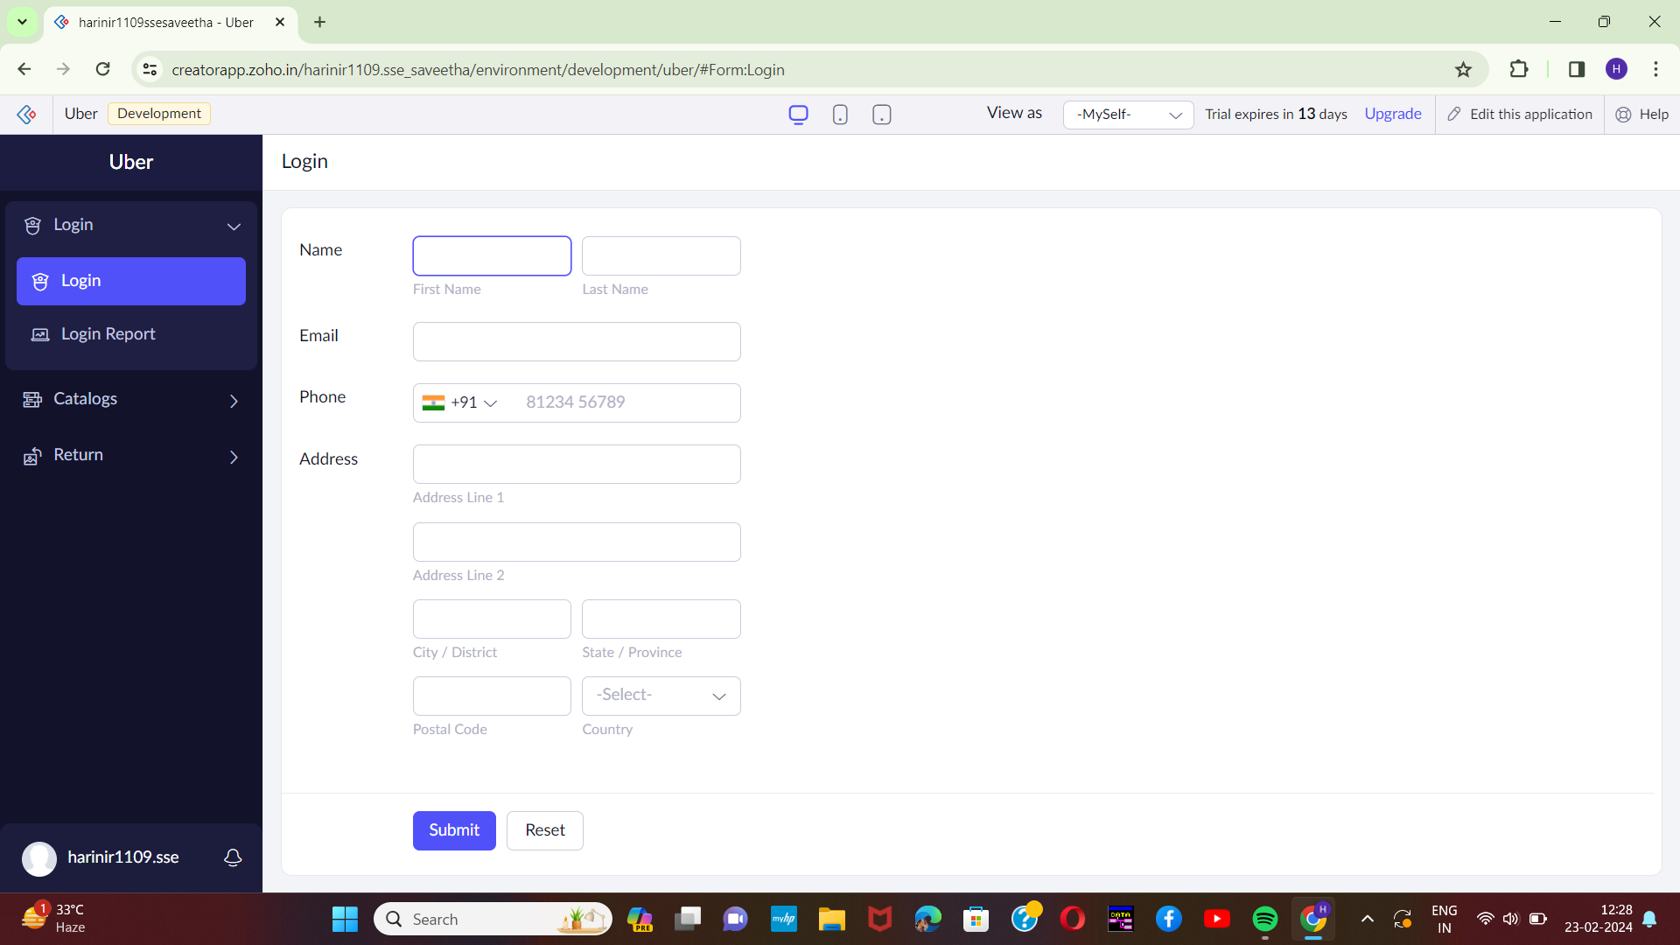[2]

STEP-3:

Next step is to add another form which consists of a book catalogue with the fields.

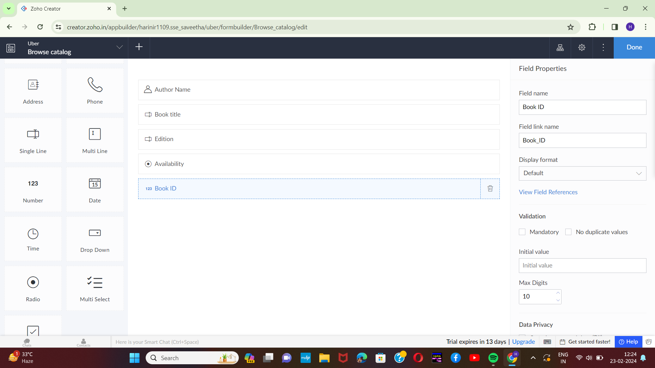

[3]STEP-4:

Execute or run the model and get the required catalogue details from live.

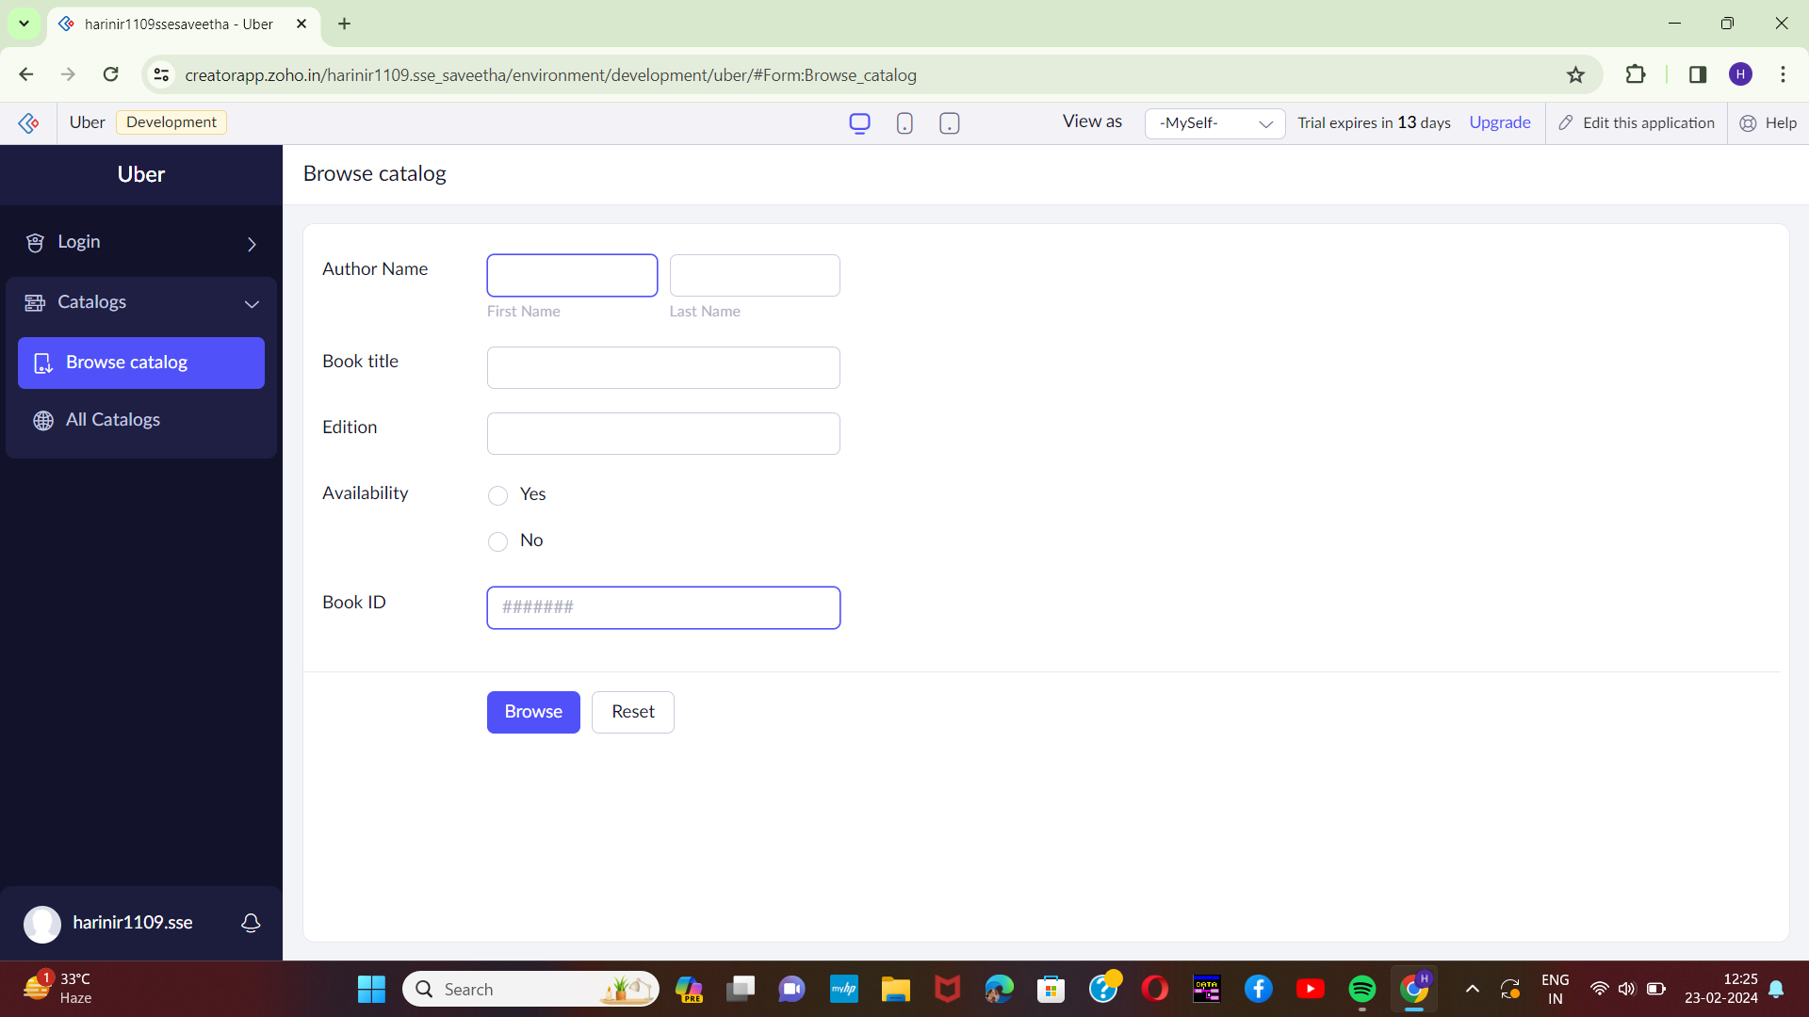

STEP-5:

Next step is to add another form which consists of return details with the fields.

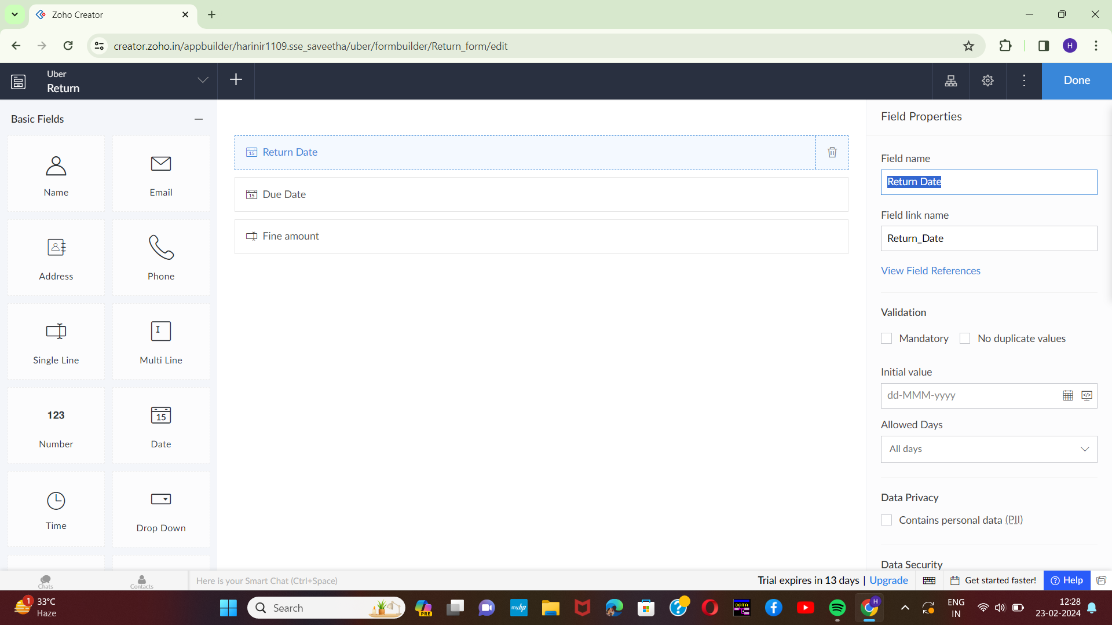

[4]

STEP-6:

Execute or run the model and get the return details from live.

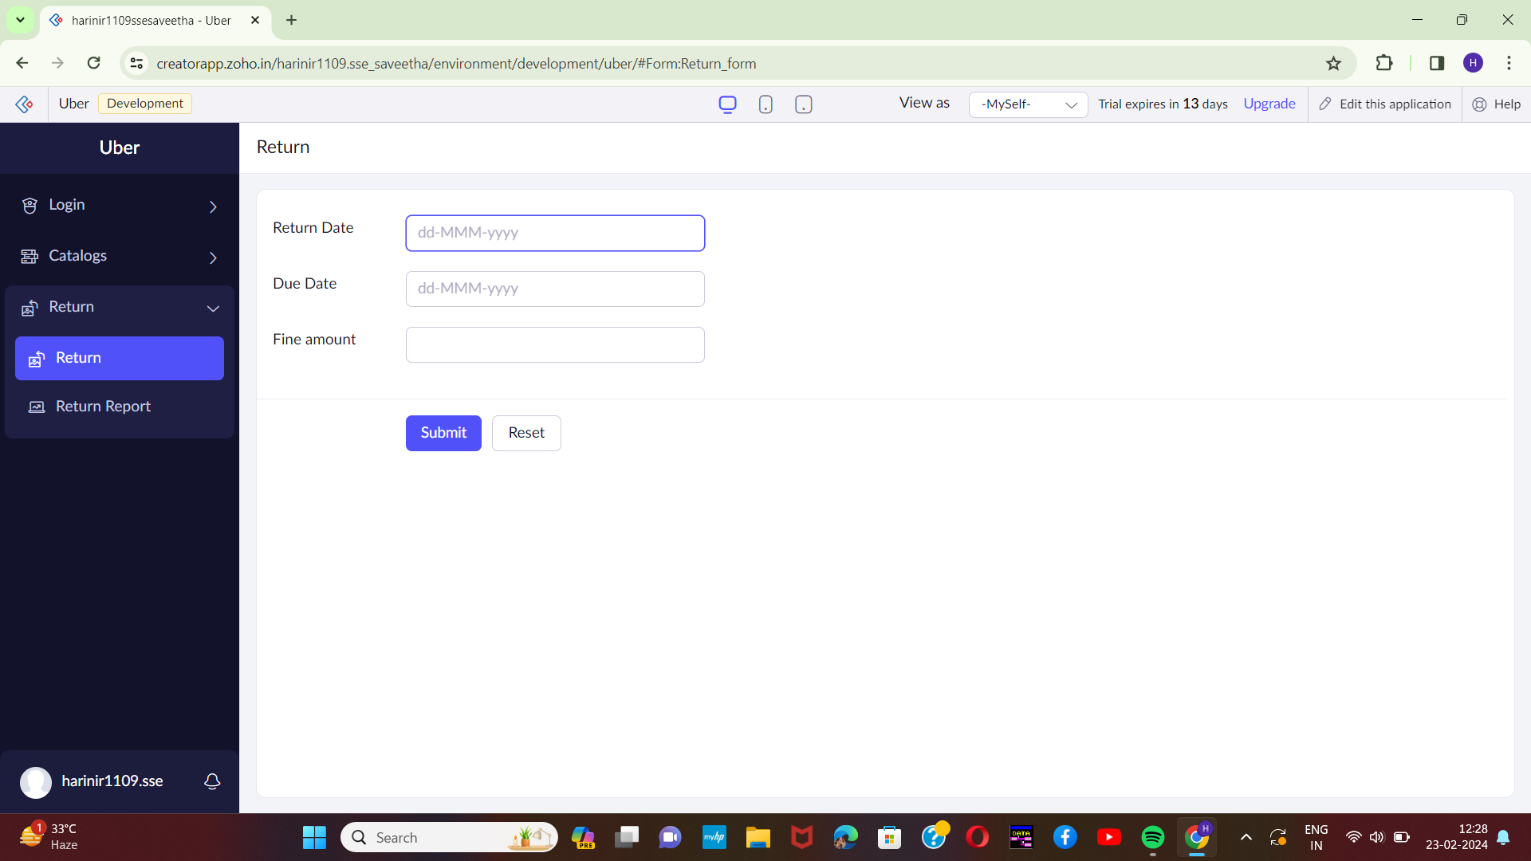

STEP-7:

Next step is to add another form which consists of logout details.

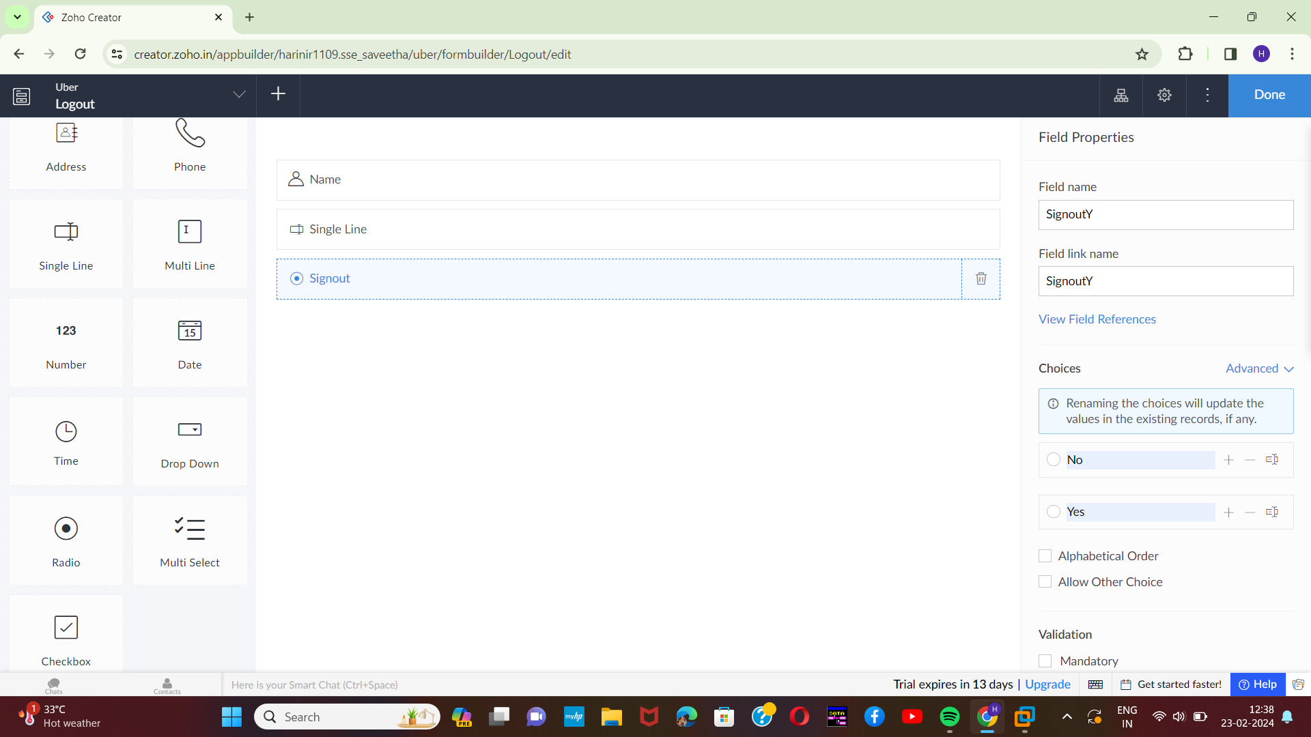[5]

STEP-8:

The last step is to run and execute the logout details form and end the program.

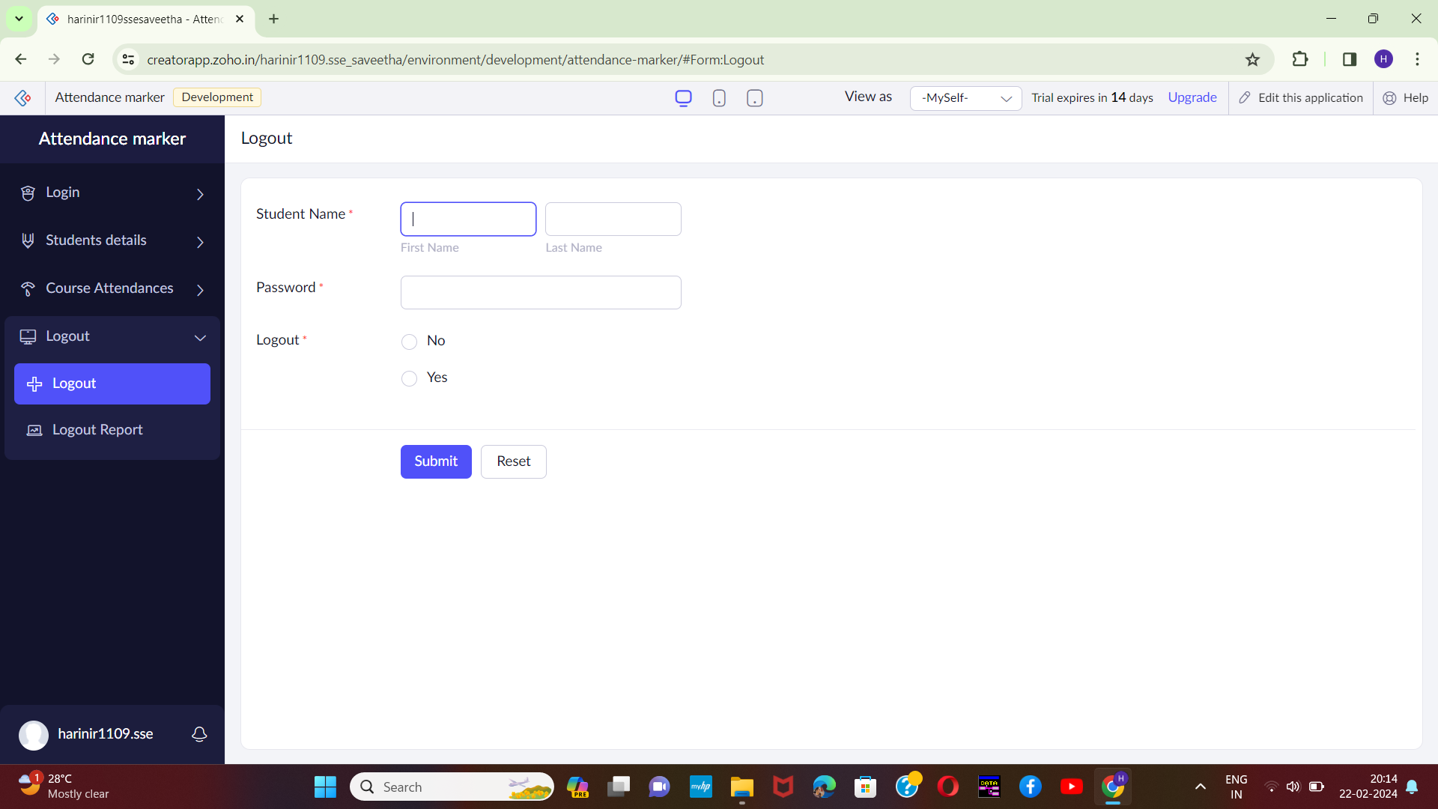

1. Harini 192221109
2. Harini 192221109
3. Harini 192221109
4. Harini 192221109
5. Harini 192221109